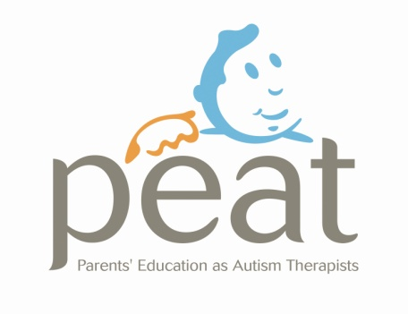

Gift Aid it

Charity Number XR24761

Through Gift Aid your PEAT membership subscription is worth 28% more!

Using Gift Aid means that we get an extra 28% from the Inland Revenue, helping your Peat membership go further.

This means that £20 can be turned into £25.60. Last year gift aid helped raise extra funds for the PEAT charity helping us to improve our services to families.

Just fill in the form below. Imagine the difference that could make, and **there is no extra cost to you!**

***Gift Aid Declaration***

**Details of Donor: (Parents)**

Title Forename (s) Surname

Address

Post Code Telephone No:

I want the Charity to treat:

* All membership subscriptions/ donations I make from the date of this declaration until I notify you otherwise as Gift Aid Donations.

Signature Date / /

Notes

You must pay an amount of income tax and/or capital gains tax at least equal to the tax that the charity reclaims on your donations in the tax year (currently 28p for each £1 you give). You can cancel this declaration at any time by notifying the charity. If in the future your circumstances change and you no longer pay tax on your income and capital gains equal to the tax that the charity reclaims, you can cancel your declaration.

Please notify the charity if you change your name and address. **ADDRESS**: PEAT, 689 Springfield Road, Belfast, BT12 7HG. **TEL**: 028 90324882, **EMAIL**: info@peatni.org